Unit 1 Notes, Part 1 - Population and Community Ecology Questions

- Describe the difference between exponential and logistic growth. Draw a simple graph for each type of growth (x-axis: time, y-axis: number of organisms).

- Which of the following graphs depicting logistic growth is more likely for a REAL population? Use the term carrying capacity in your response.

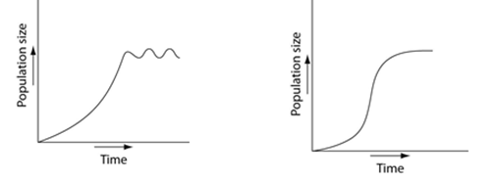

- Describe the differences in the survivorship curves between r-selected and k-selected populations.

- Describe the age structure of each of the populations of each of the three countries shown below—Afghanistan, the United States, and Italy.

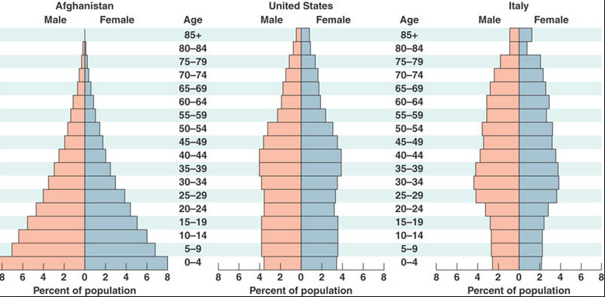

- Describe the population growth rate in each of the three countries based on their age structure pyramids.

- When slug species A and slug species B live in the same community, Species A eats leaves and species B eats moss. When species B is removed from the community, Species A eats both leaves and moss. What can you infer about the fundamental and realized niches of species A and species B in this community?

- If there are 34 KJ of energy stored in organisms at the quaternary consumer level, how many KJ of energy are stored at the primary consumer level within this community?

- Describe the difference between gross primary productivity and net primary productivity.

- How do we determine species diversity? Describe a situation in which a community would be considered highly diverse.

- Create a table depicting the following information (each category should be its own column): Type of symbiotic relationship, effect on each species (use 0,+,-), real life example.

