Discovering Heritable Material

Big Idea: living systems store, retrieve, transmit, and respond to information critical to life processes.

Question:
- How is information passed between living organisms?

In 1928, Frederick Griffith, who was studying Streptococcus pneumoniae to find a vaccine for pneumonia, made a startling observation. Griffith had two strains of the bacterium, a pathogenic or disease-causing strain and a second harmless one. Bacteria of the “S,” or “smooth,” strain are pathogenic because a protein capsule protects them from an animal’s defense system; bacteria of the “R,” or “rough,” strain lack a capsule and are nonpathogenic.

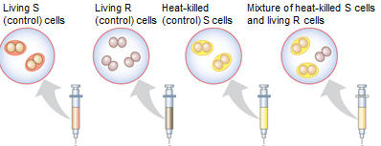

Predict what will happen if each of the above are injected into a mouse (live or die ):
- Living S Cells- _________
- Living R Cells- ________
- Heat-killed S cells- _______
- Mixture of heat-killed S and living R cells- _______

Explain Griffith’s results:

How can the concept of transformation benefit humans?

Question: What molecule is the source of this heritable information?

T. H. Morgan and his co-researchers showed that Mendel’s traits (genes) are located on chromosomes, the two chemical components of chromosomes—DNA and protein—became the candidates for the genetic material

- Alfred Hershey and Martha Chase performed a series of experiments with a bacteriophage known as T2. Phage T2 infects Esherichia coli, a common bacterium that lives in the intestines of animals.

- Previous studies had shown that T2 was composed of DNA and protein; that it could turn an E. coli cell into a T2-producing factory; and that somehow T2 could reprogram its host cell to produce viruses
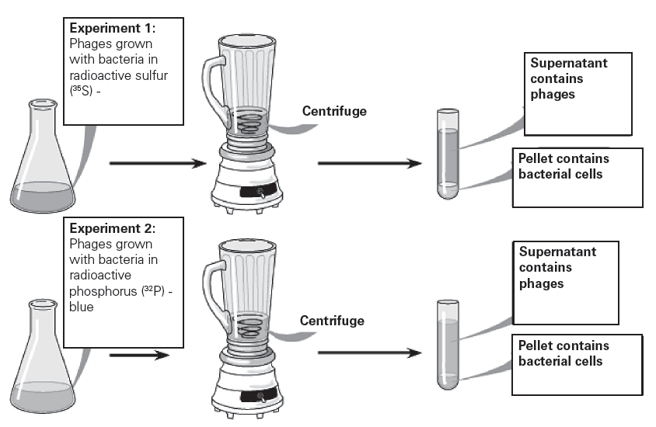

Why did Hershey and Chase use radioactive Sulphur in one experiment but radioactive Phosphorus in the other?

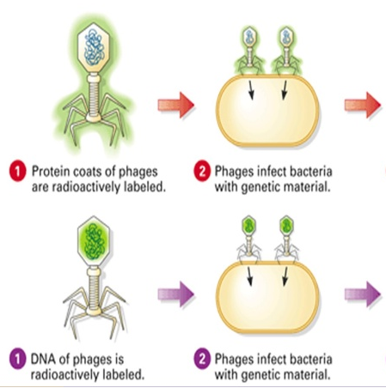

Where was radioactive sulfur found at the end of experiment 1 (still in virus or in bacteria)?

Where was radioactive Phosphorus found at the end of experiment 2 (still in virus or in bacteria)?

What does this experiment show about how genetic information is passed along?

