Name: _____________________________________ Date: _______________________ Period: ______

**Population Growth Equations Practice Worksheet**

Ms. OK, AP Biology, 2014-2015

**Formulas:**

***Rate Population Growth Exponential Growth Logistic Growth***

dY/dt dN/dt = B – D  

**Key**

dY = amount of change

B = birth rate (# f organisms born / 1 year)

D = death rate (# of organisms died / 1 year)

N = population size (# of organisms in the population)

K = carrying capacity (maximum number of organisms that the environment can sustain)

rmax = maximum per capita growth rate of population (decimal value, a value of 1 means that the population size is doubling or increasing by 100% each year)

 =  =  = number of organisms added per unit time (ex: per year)

**Practice Problems**

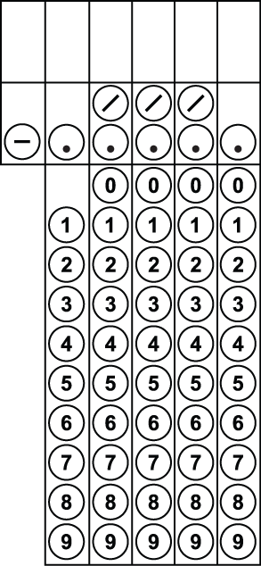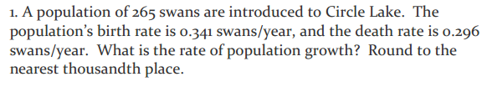

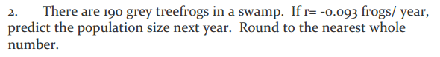

3. One dandelion plan can produce many seeds, leading to a high growth rate for dandelion populations. If a population of dandelions is currently 40 individuals and rmax =0.8, predict dN/dt (per month) if these dandelions would grow exponential. Round to the nearest whole number.



4. Imagine the dandelions mentioned in #3 cannot grow exponentially, due to lack of space. The carrying capacity for their patch of lawn is 70 dandelions. What is their dN/dt in this logistic growth situation? Round to the nearest whole number.



5. A hypothetical population has a carrying capacity of 1,500 individuals and rmax is 1.0. What is the population growth rate for a population with a size of 1,600 individuals? Round your answer to the nearest hundredth.



6. There are 2,000 mice living in a field. If 1,000 mice are born each month and 200 mice die each month, what is the per capita growth rate of mice over a month? Round your answer to the nearest tenth.

*Note: This worksheet is adapted from various sources. Thank you!*